1. Execute and display the results for the following commands in Kali Linux Operating
Systems:

rm command
users command

tree command
Aim
To execute and display the results of the rm, users, and tree commands in Kali Linux.

1. RM COMMAND
Command:
rm sample.txt
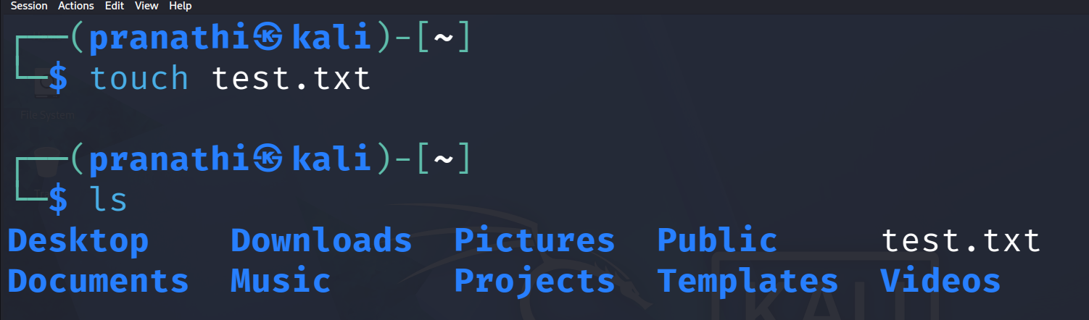
Use:
The rm command is used to remove or delete files and directories.
2. USERS COMMAND
Command:
users
Use:
The users command is used to display the users currently logged into the system.
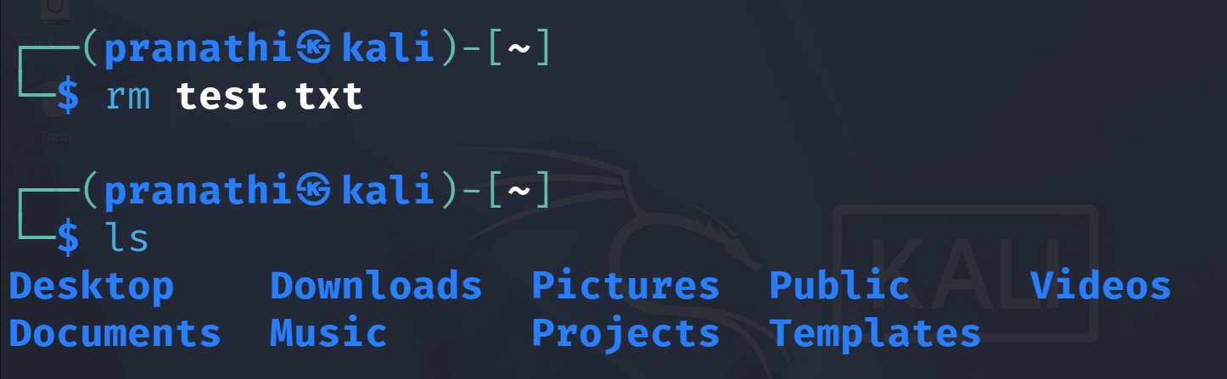
3. TREE COMMAND
Command:
tree
Use:
The tree command is used to display the directory and file structure in a tree-like format.
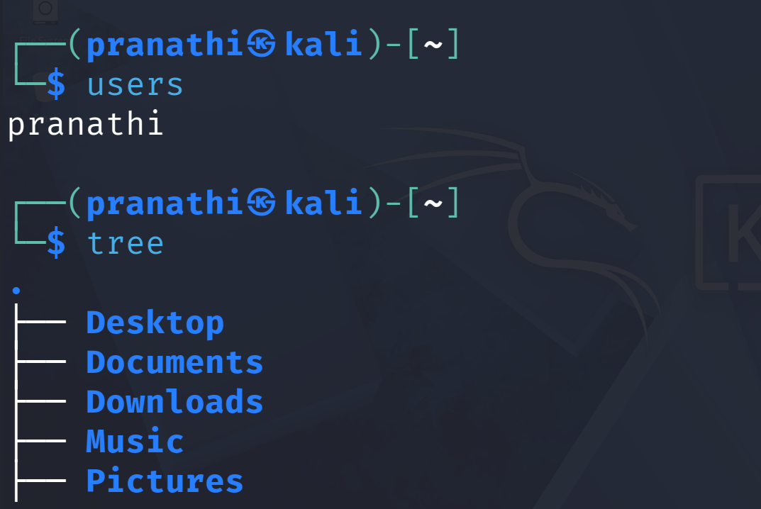
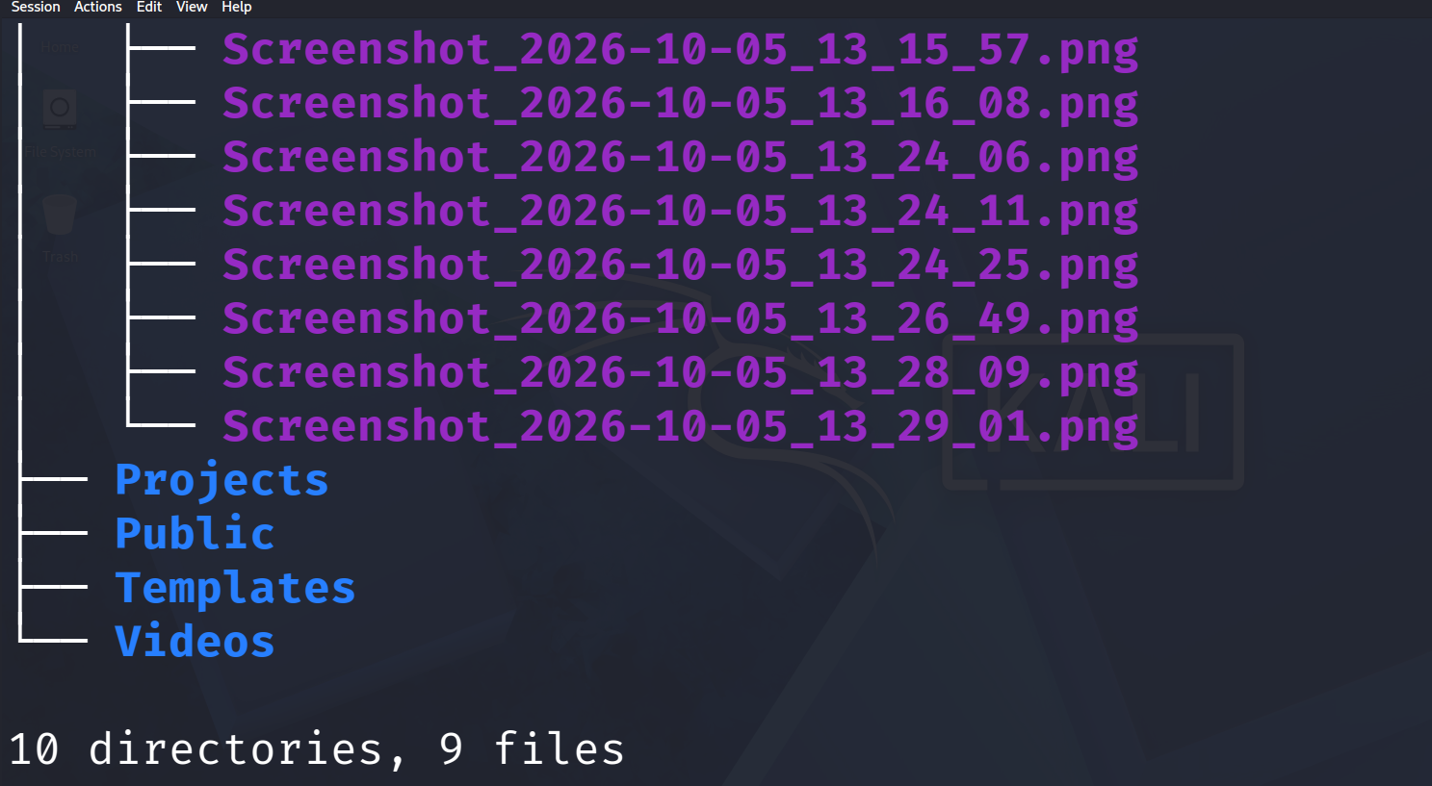

Result
Thus, the rm, users, and tree commands were successfully executed in Kali Linux and their results were displayed.

